
Saad Mughal
F2023-009
Total Marks: 10
Due 29 April 2026

Computer Networks LAB

Week 10

DHCP Server, Client & Relay Agent

Course Lecturer: Shaiza Rizwan
Lab Instructor: Hasnain Ahmad
Section: C

Computer Networks LAB (LAB-209) - Lab 08
DHCP Server, Client & Relay Agent

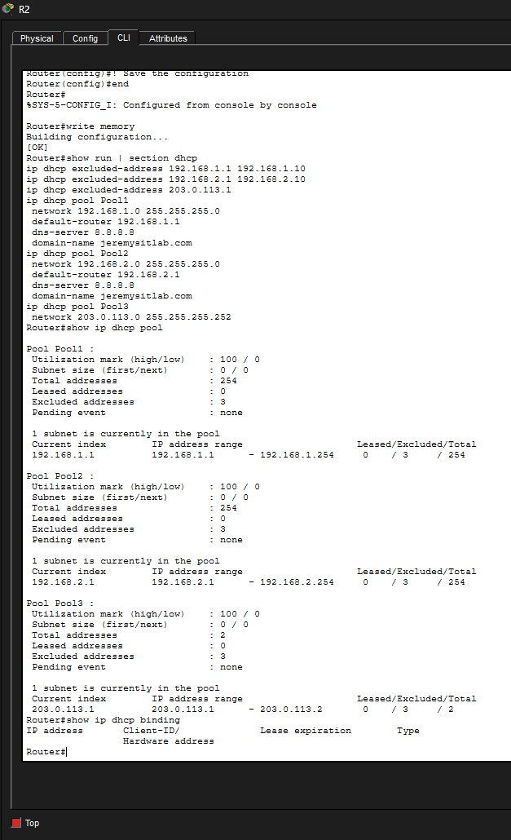
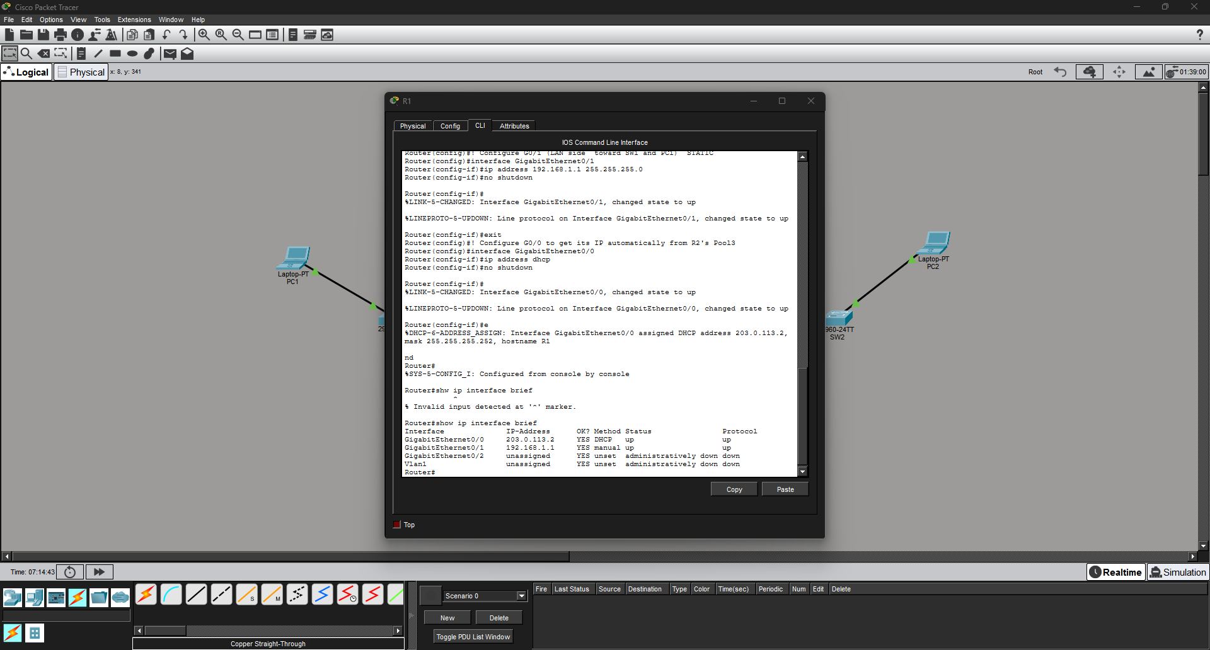
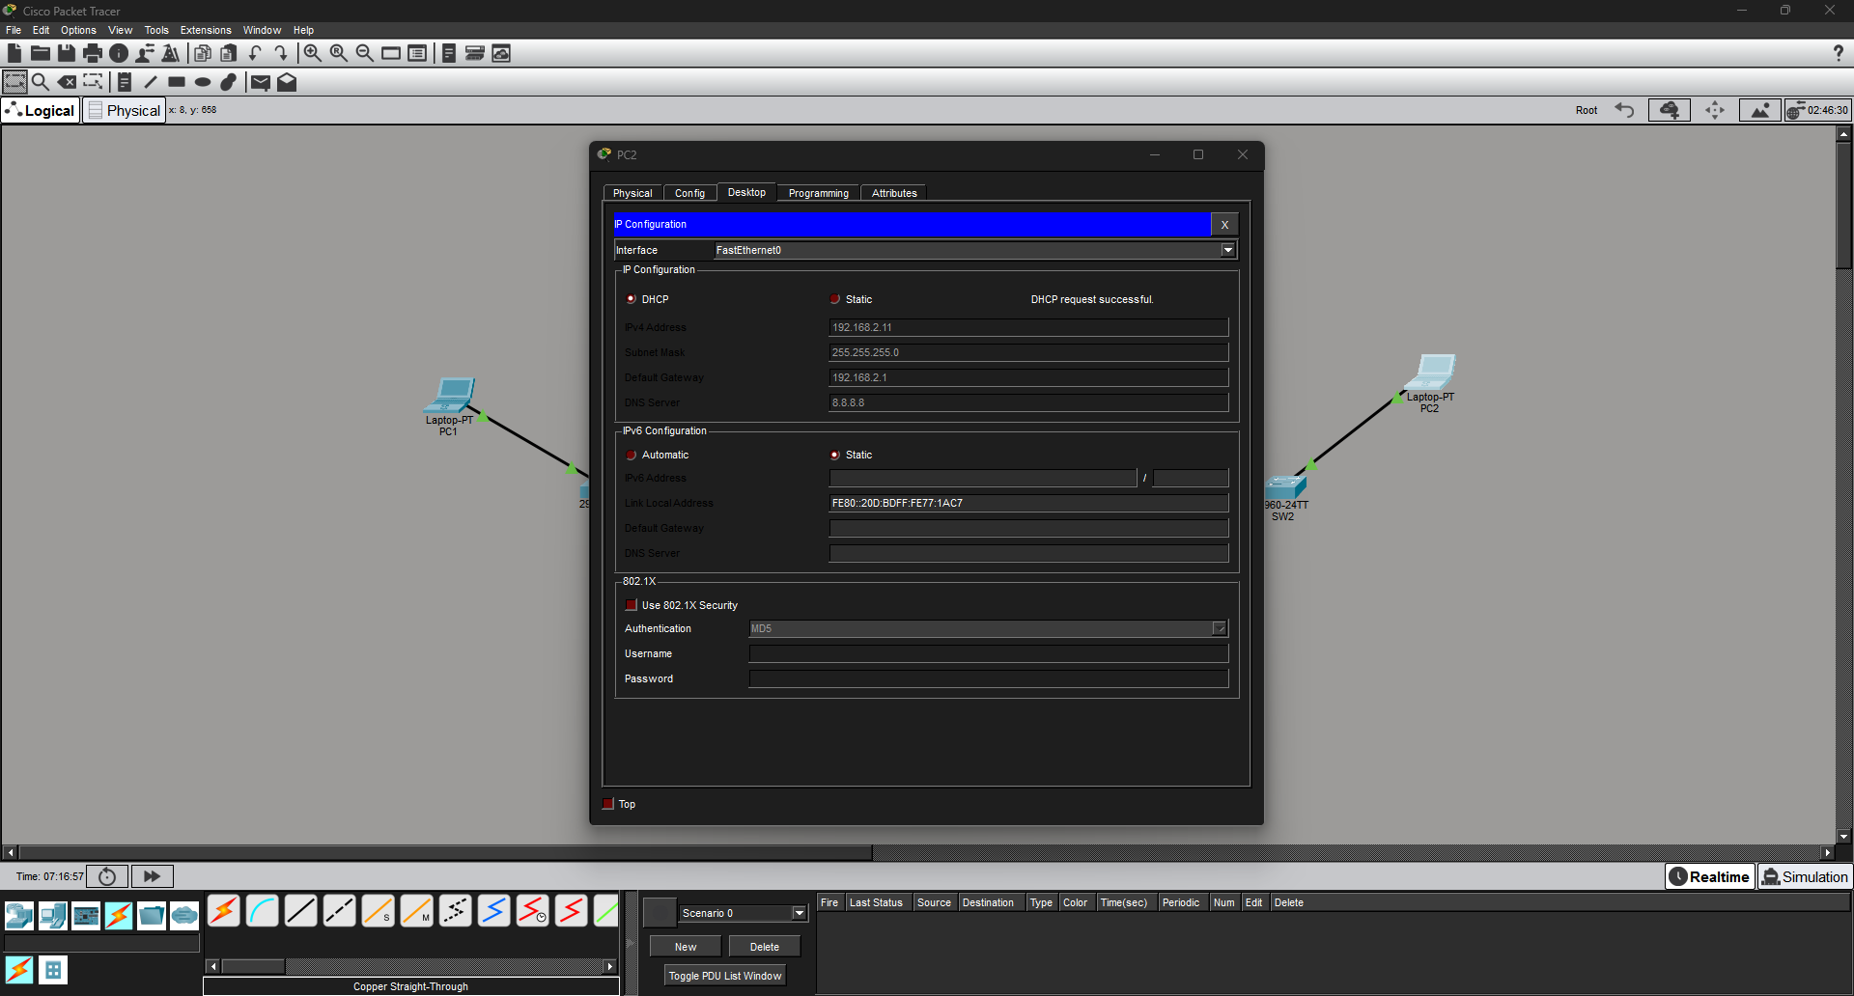
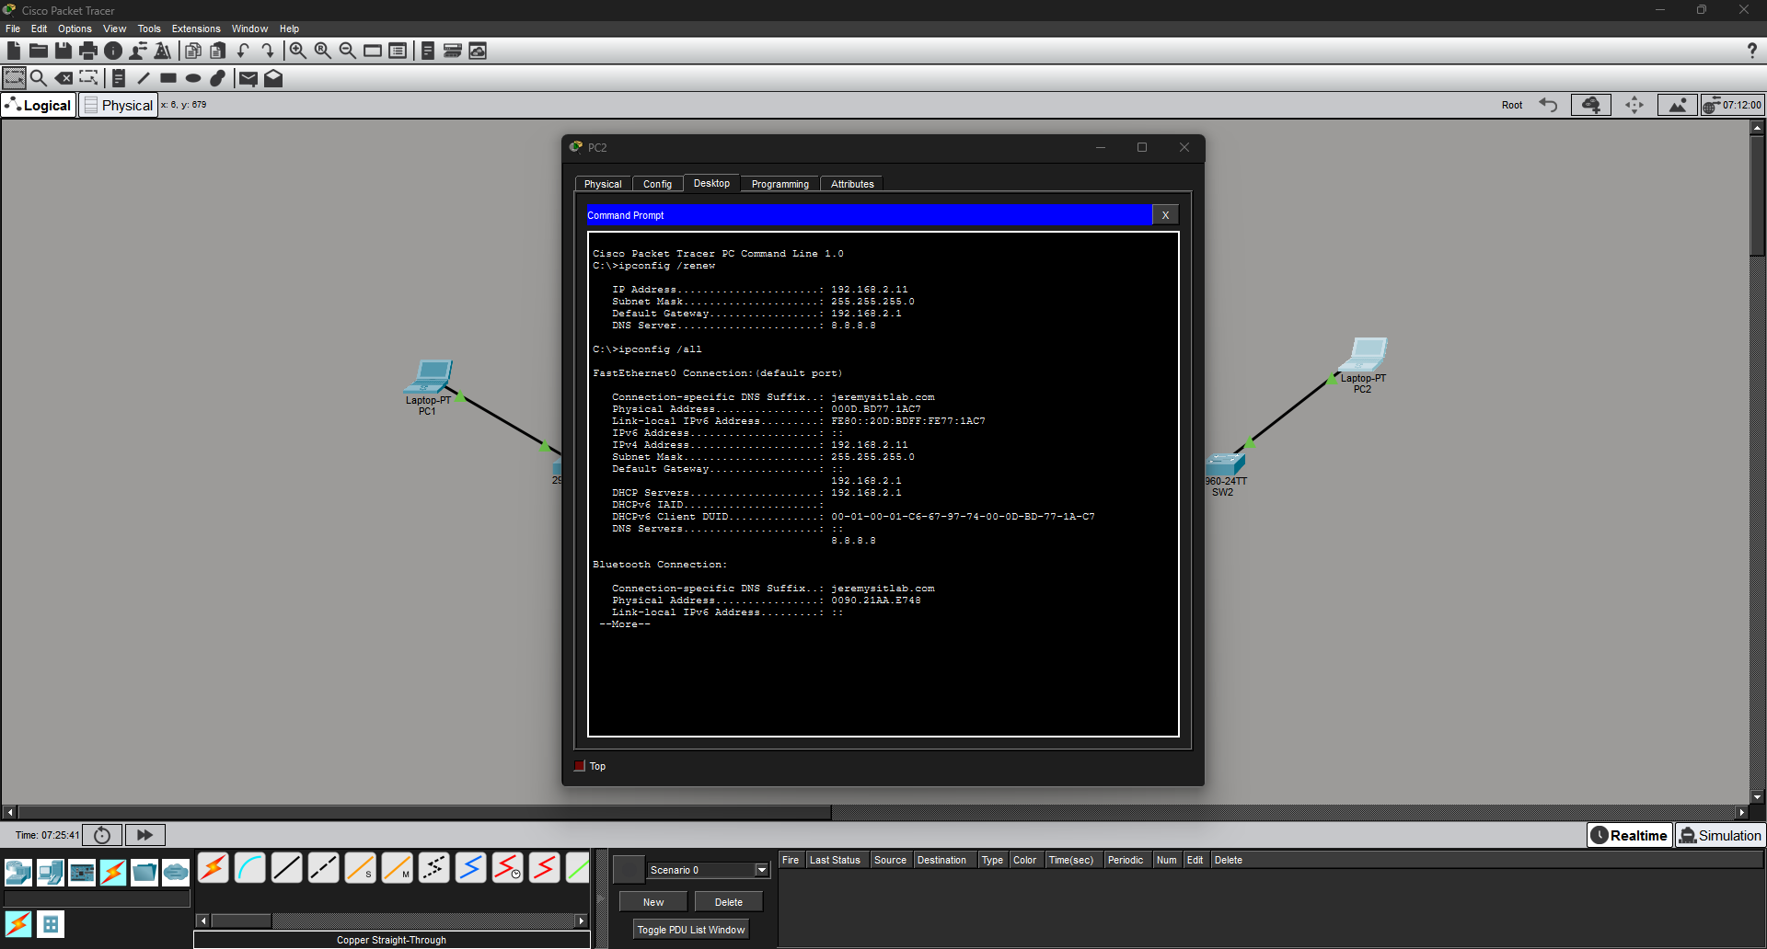
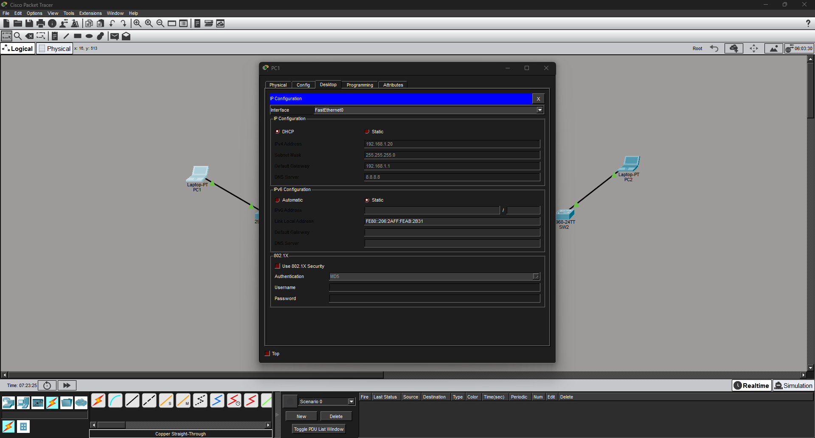
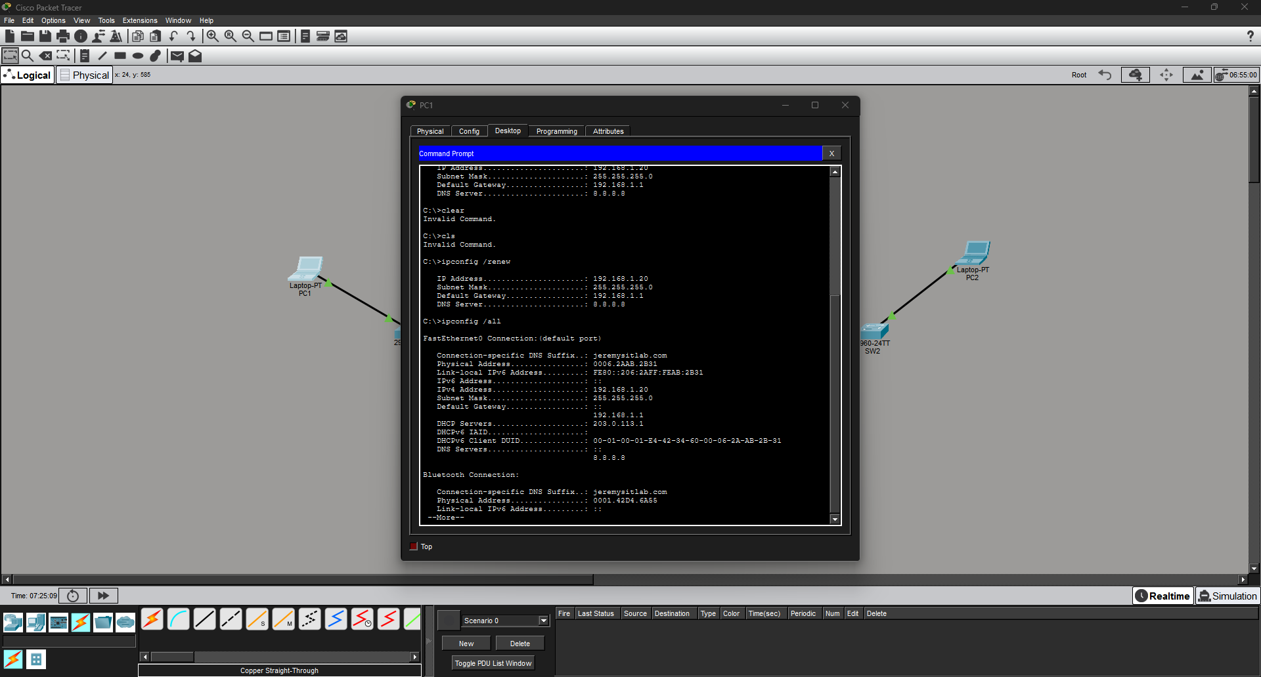
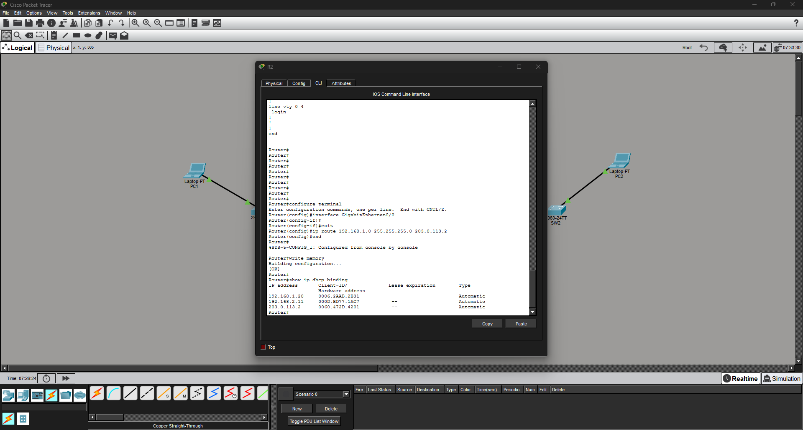
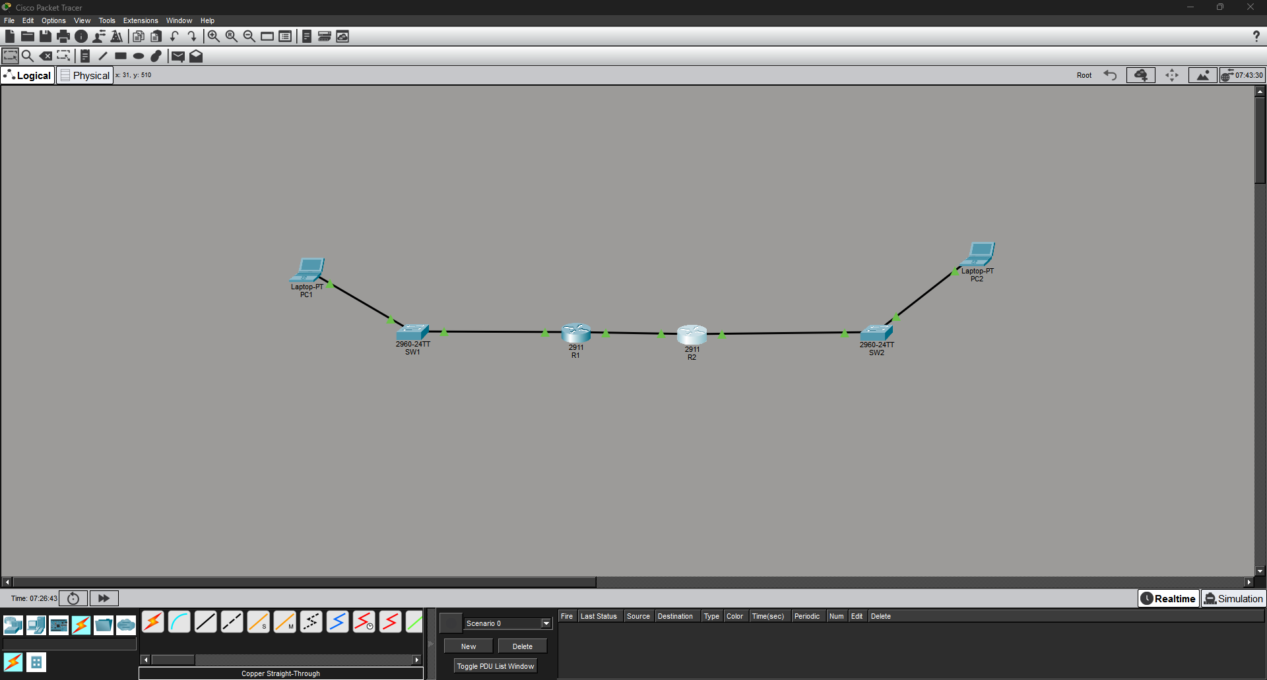

Task 1 Question: After running show ip dhcp binding, what IP address did PC2 receive? Write it here:
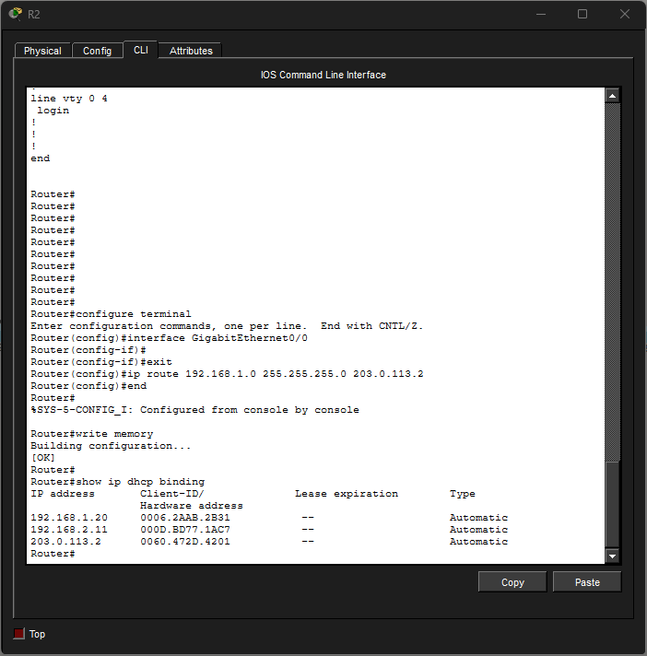
Task 2 Question: What IP address did R1’s G0/0 interface receive from R2’s DHCP Pool3? Why is this the only possible IP it could receive?
Answer: R1's G0/0 received 203.0.113.2. This is the only possible IP because Pool3 uses the /30 subnet 203.0.113.0/30, which has only 2 usable host addresses: .1 and .2. The .1 address (203.0.113.1) was excluded with ip dhcp excluded-address, leaving .2 as the only address the server can assign.
Task 3 Question: In your own words, explain why ‘ip helper-address’ is needed in this topology. What problem does it solve?
Answer: By default, routers do not forward broadcast packets between subnets. DHCP uses broadcasts (DHCP Discover messages) that PC1 sends on the 192.168.1.0/24 subnet. Without a relay agent, R1 would simply drop these broadcasts and they would never reach R2 (the DHCP server) on a different subnet. The ip helper-address command on R1's G0/1 solves this by intercepting those DHCP broadcasts and converting them into unicast packets addressed directly to R2 (203.0.113.1), allowing R2 to respond and assign an IP to PC1 even though they are on different subnets.
Task 4 Question
Device | IP Address Received | Default Gateway | Pool Used
PC1 | 192.168.1.20 | 192.168.1.1 | Pool1
PC2 | 192.168.2.11 | 192.168.2.1 | Pool2

